Design of Electrical Power Meter  
for Alternating Current 1 Phase Source

Dina Mentari1*, Muarofatul Isnaini2, M. Nur Sulaiman3

1-3Electrical Engineering, Faculty of Engineering and Informatics, Universitas Gajayana Malang Indonesia

Email: 1) [mentari.dina08@gmail.com](mailto:mentari.dina08@gmail.com), 2) [muarofatulisnaini8@gmail.com](mailto:muarofatulisnaini8@gmail.com),

3) [mnslman@unigamalang.ac.id](mailto:mnslman@unigamalang.ac.id)

|  |  |  |  |
| --- | --- | --- | --- |
| **Received:**  January 10, 2025 | **Revised:**  January 30, 2025 | **Accepted:**  February 10, 2025 | **Online:**  February 14, 2025 |
| **Abstract**  Electricity utilization plays a significant role in shaping the power distribution system. Single-phase electricity is a common form of alternating current (AC) supply that is predominantly found in various applications within households and small industries. This type of power is essential for operating household appliances like refrigerators, washing machines, and air conditioners, as well as powering small businesses and workshops. Electrical load power measurements are carried out using a wattmeter or powermeter. This tool can help control lighting systems remotely and monitor household energy. Designed for measurement of electrical power consumed by electrical loads. Using voltage, current, phase sensors and an ATMega328 microcontroller to process data. The LCD screen will display data on electrical power consumption based on measurements of current and voltage. This innovative prototype is designed to offer users insights into their electricity usage habits, ultimately encouraging more efficient energy usage. The goal is to empower individuals to make informed decisions about their energy consumption and contribute to a sustainable future.  **Keywords**: Electric Power, Single-phase, Measurement | | | |

1. Introduction

Measurements are made to determine the value of the quantity to be measured. The goal is to get correct data and can be applied to various sciences. According to Stevens (1971), measurement is an activity to determine a value for the observed object. Electronic measurements can support technological advances, as well as a solution to remote measurements (Balestrieri et al., 2021; Hernandez-Jayo & Garcia-Zubia, 2016). However, development needs to be done to design tools to expand the existing library (Hernandez-Jayo & Garcia-Zubia, 2016; Iksal et al., 2018).

The increase in electrical load power is due to the increase in population, the increase in the number of electrical appliances, and the increase in the use of large power electrical appliances (Adityawarman et al., 2014). Thus, a measuring instrument is needed to measure electrical load power in order to reduce negative impacts (Butti, 2013). Among them are increased electricity costs, decreased voltage quality, damage to electrical equipment, and damage to the electricity network (Syahputra et al., 2020). With this tool, it is expected to be able to measure electrical power with more accurate accuracy than existing measuring equipment.

1. Methods

Methods in designing this tool, including designing hardware and software. In the design of the electric load power measuring instrument in this home environment which is expected to help measure the power of the electric load to help the lights that are on with the control process automatically.accommodating the results of electric load power (Wibowo et al., 2023). Perform data reading. Able to calculate the electrical load power properly. The hardware design starts with making a circuit block diagram that describes the components and data flow. Next, circuit design is carried out for each component according to its function (Feucht, 1990).

* 1. Hardware Design

Presents the functional units needed to realise the design. The following diagram is shown:

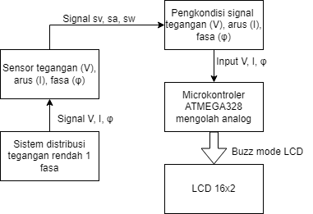

Figure 1. Hardware Block Diagram

The design of the voltage sensor aims to sense the 220 V grid voltage. PLN Electric voltage of 2000 with a tolerance of 10% of the nominal phase-neutral voltage.

Minimum phase-neutral voltage, VLmin = 220 - 10%.220 = 198 V

Maximum phase-neutral voltage, VLmax = 220 + 10%.220 = 242 V

This current sensor design, the load current that measures comes from household loads. Assuming the maximum power of the resistive load is 350 W, the maximum current flowing is:

ILmax = 350/220 = 1.59 A

The maximum voltage produced by the CT, VImax, is

VImax = 0.333 . 1,59 = 0,053 V

In peak value, VImaxpeak = VImax . √2 = 0.07495 V

This peak value is used to determine the gain of the VI conditioning circuit.

Phase sensor design To determine the phase of voltage and current, a phase sensor is required. The sine voltage produced by the voltage sensor, Vv, and the current sensor, VI, is converted into a square wave to define the zero cross. Both are compared digitally by an EXOR gate to define the phase. The resulting pulse width will indicate the phase of the voltage and current.

* 1. Software Design

Presenting reasoning or algorithms, here is the diagram shown:

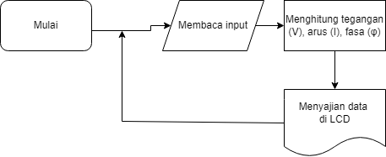

Figure 2. Software System Block Diagram

In the software design using the Arduino IDE as a programme to display power, namely:

In the overall test, what is displayed is the voltage and current values from the programme as follows:

#include <LiquidCrystal.h>

// Pins for current sensor

const int pinArus = A4;

// Pins for voltage sensor

const int pinTegangan = A5;

// Pin for LCD

const int pinLCD_RS = A2;

const int pinLCD_EN = A0;

const int pinLCD_D4 = 12;

const int pinLCD_D5 = 11;

const int pinLCD_D6 = 10;

const int pinLCD_D7 = 9;

LiquidCrystal lcd(pinLCD_RS, pinLCD_EN, pinLCD_D4, pinLCD_D5, pinLCD_D6, pinLCD_D7);

// Pin untuk LCD

float Vin;

float VS;

float IL;

const int Vref;

const int R2;

const int R3;

const int RL;

const int RS;

int DataADC;

void setup() {

// put your setup code here, to run once:

//Inisialisasi LCD

Serial.begin (9600);

lcd.begin(16, 2);

}

void loop() {

// put your main code here, to run repeatedly:

//lcd.setCursor(12, 0);

//lcd.print(millis() / 1000);

analogReference (DEFAULT);

//lcd.print(0.00489*analogRead(A5)/1);

//lcd.print = (analogRead(A5));

DataADC = analogRead(A5);

//Vin = (float)DataADC*(float)5/1023;

VS = (float)DataADC*0.09775;

IL = (float)DataADC*4.88;

//lcd.print ("DataADC");

// lcd.print ("Vin") ;

delay(1000);

lcd.setCursor (0,0);

lcd.print("VS = ");

lcd.print(VS);

lcd.setCursor (0,1);

lcd.print("IL = ");

lcd.print(IL);

//Serial.print ("VS = ");

//Serial.println (VS);

//Serial.print ("IL= ");

//Serial.println (IL);

}

1. Results and Discussion

The following are the results and discussion of several simulation tests that have been carried out from several circuits:

* 1. Voltage circuit

The voltage sensor used is a voltage transformer. The test aims to determine the comparison of the primary voltage and secondary voltage of the voltage transformer. It is expected that the voltage transformer can provide a secondary voltage of 3.53 V when the primary voltage is maximum (240 V).

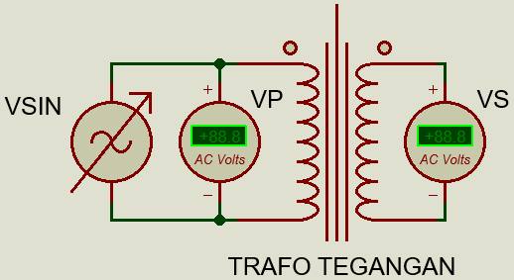

Figure 3. Voltage Sensor Experiment

From the above circuit, the simulation test results are obtained in the following table:

Table 1. Measurement of Voltage Sensor using YX-329TR multimter

|  |  |  |
| --- | --- | --- |
| No | Primary Voltage | Secondary Voltage |
| 1. | 160 V | 2,2 V |
| 2. | 190 V | 2,6 V |
| 3. | 220 V | 2,9 V |
| 4. | 230 V | 3,1 V |
| 5. | 240 V | 3,2 V |

Source: Author’s

* 1. Current Circuit

Current sensor testing aims to determine the comparison of the primary voltage and secondary voltage of the current transformer (Wahyu Suryawan et al., 2012). Testing is done by giving variations in current and measuring the voltage output. Measurements are made by utilising an AC ampermeter and AC voltmeter.

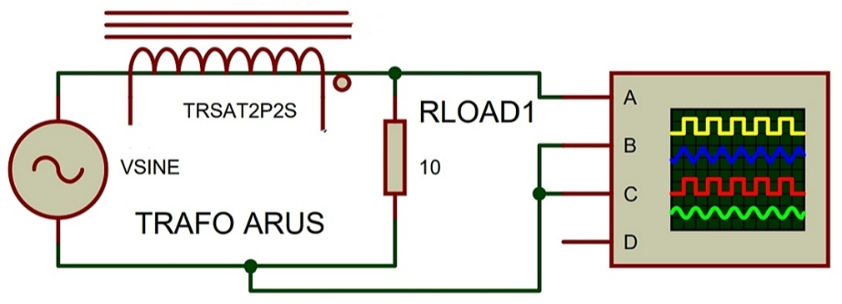

Figure 4. Current Sensor Test Results

From the above circuit, the simulation test results are obtained in the following table:

Table 2. Current Sensor Measurement Table using resistive load

|  |  |  |  |
| --- | --- | --- | --- |
| **No** | **Input** | | **Output** |
| **Voltage** | **Current** |
| 1. | 33 V | 0,5 A | 75,8 mV |
| 2. | 132 V | 2 A | 147 mV |
| 3. | 165 V | 2,5 A | 168 mV |
| 4. | 198 V | 3 A | 187 mV |

Source: Author’s

* 1. Phase Circuit

The phase sensor test aims to determine the relationship of pulse width, tPW, and phase between two input signals, VV and VI. The input signal source uses a sine signal generator connected to a series RC circuit as a phase shifter. The amplitude of the generator is set as high as 5 Vpp and the frequency is 50 Hz.

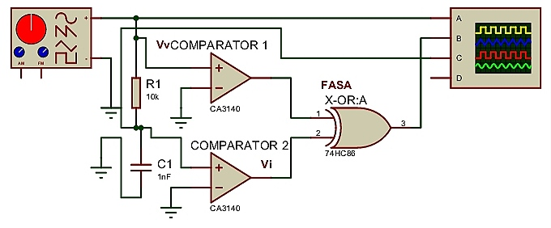

Figure 5. Phase Sensor Test Results

From the above circuit, the simulation test results are obtained in the following table:

Table 3. Phase measurement

|  |  |  |  |  |
| --- | --- | --- | --- | --- |
| **No.** | **Resistor** | **Capasitor** | **Phase Difference** | **Pulse Width tw** |
| 1. | 10 kΩ | 100 nf | 17,2 ° | 993 µS |
| 2. | 22 kΩ // 27 kΩ | 100 nf | 21,06 ° | 1,17 mS |
| 3. | 22 kΩ | 100 nf | 33,48 ° | 1,95 mS |
| 4. | 27 kΩ | 100 nf | 39,06 ° | 2,31 mS |
| 5. | 32 kΩ | 100 nf | 44,1 ° | 2,53 Ms |
| 6. | 37 kΩ | 100 nf | 46,44 ° | 2,74 Ms |

Source: Author’s

1. Conclusion

The electrical power measurement system designed in accordance with the planned needs produces several important conclusions. The voltage, current, and phase measurements taken will display the power measurement results, the data obtained will be stored on the microcontroller and displayed in the form of numbers on the LCD. In addition, the greater the load given, the higher the error results obtained.

As a suggestion for further research, it is recommended to use stronger components to reduce the risk of fire, choose resistive loads to get more accurate measurement results, and use sturdier materials so that the tool is not easily burned or damaged.

1. References

Adityawarman, D., Zebua, O., & Hakim, L. (2014). Rancang Bangun Alat Ukur Arus Menggunakan Transformator Arus Berbasis Mikrokontroler Atmega32. *Electrician: Jurnal Rekayasa Dan Teknologi Elektro*, *8*(2), 45–56.

Balestrieri, E., Daponte, P., De Vito, L., & Lamonaca, F. (2021). Sensors and measurements for unmanned systems: An overview. In *Sensors* (Vol. 21, Issue 4). https://doi.org/10.3390/s21041518

Butti, F. (2013). *Design of low power, low noise instrumentation amplifiers for MEMS sensor interfacing.* University of Pisa, Italy.

Feucht, D. L. (1990). Handbook of Analog Circuit Design. In *Handbook of Analog Circuit Design*. https://doi.org/10.1016/c2013-0-10649-6

Hernandez-Jayo, U., & Garcia-Zubia, J. (2016). Remote measurement and instrumentation laboratory for training in real analog electronic experiments. *Measurement: Journal of the International Measurement Confederation*, *82*. https://doi.org/10.1016/j.measurement.2015.12.017

Iksal, I., Suherman, S., & Sumiati, S. (2018). Perancangan Sistem Kendali Otomatisasi On-Off Lampu Berbasis Arduino dan Borland Delphi. *Prosiding Seminar Nasional Rekayasa Teknologi Informasi| SNARTISI*, *1*.

Stevens, S. S. (1971). Issues in psychophysical measurement. *Psychological Review*, *78*(5), 426.

Syahputra, R., Yusmartato, Y., Nasution, R., & Yusniati, Y. (2020). Pengoperasian Transformator Dengan Mengunakan Tap Changer Aplikasi Gardu Induk Denai. *JET (Journal of Electrical Technology)*, *5*(2), 53–60.

Wahyu Suryawan, D., Sudjadi, & Karnoto. (2012). Rancang Bangun Sistem Monitoring Tegangan, Arus Dan Temperatur Pada Sistem Pencatu Daya Listrik Di Teknik Elektro Berbasis Mikrokontroler Atmega 128. *Transient*, *1*(4).

Wibowo, A. W., Nawawi, I., & Novianto, D. (2023). Pengukuran Daya Listrik Menggunakan Penguat Common Emitter dan Komparator. *Aviation Electronics, Information Technology, Telecommunications, Electricals, Controls*, *5*(1), 53–64.